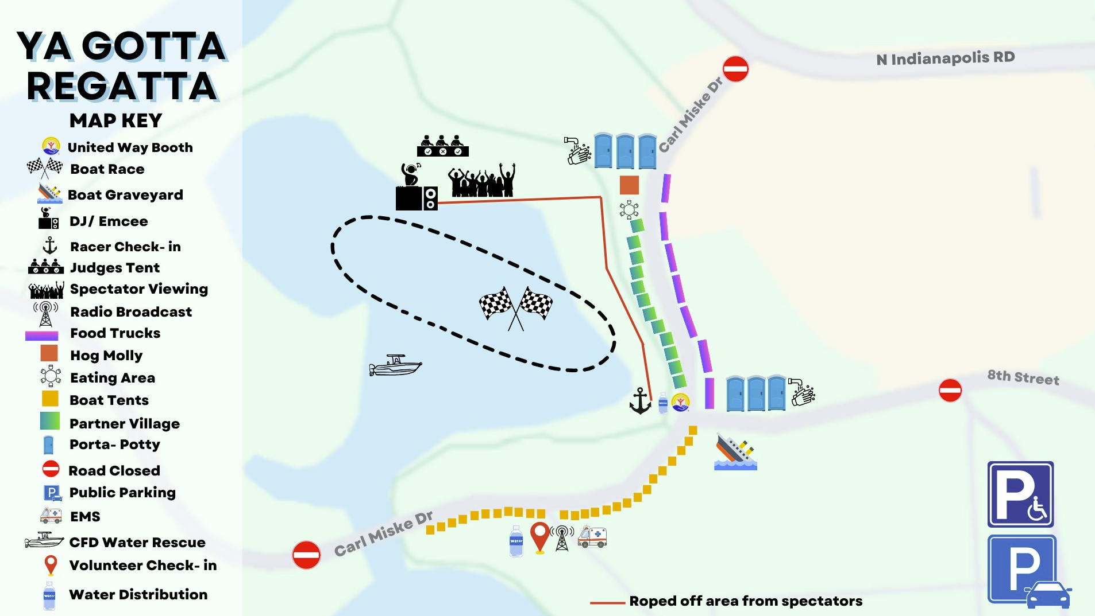
**Please note layout is not to scale

 2026 Columbus Riverfest

